2048 planning Document

# Description

2048 is a game played on a 4 by 4 tiled board. The game starts with two tiles (value 2 or 4) randomly placed on the board. All other tiles are empty. The player makes a move by choosing a direction up, down, left or right. All tiles are pushed as far as they can go in the chosen direction. Any adjacent tiles in the chosen direction with the same value combine and the value of the new tile is equal to the sum. After each move one new tile with value 2 or 4 is randomly placed on an empty location.

The goal of the game is to attain a tile with value 2048 or more. The game is over if the board becomes full and there no tiles can be combined.

# Screenshot

Beginning of game 1st move After hitting right arrow

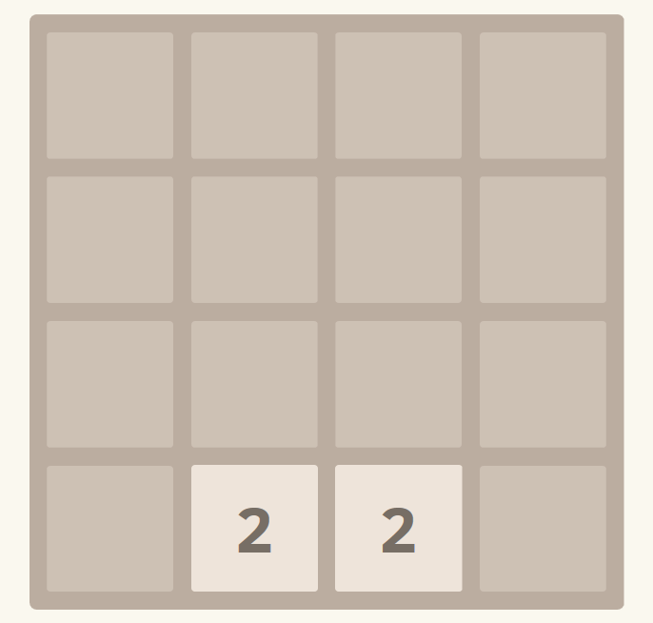 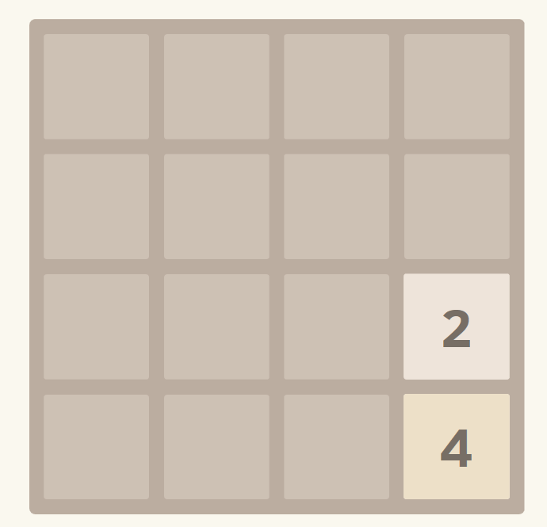

2nd move after hitting up arrow 3rd move after hitting right arrow

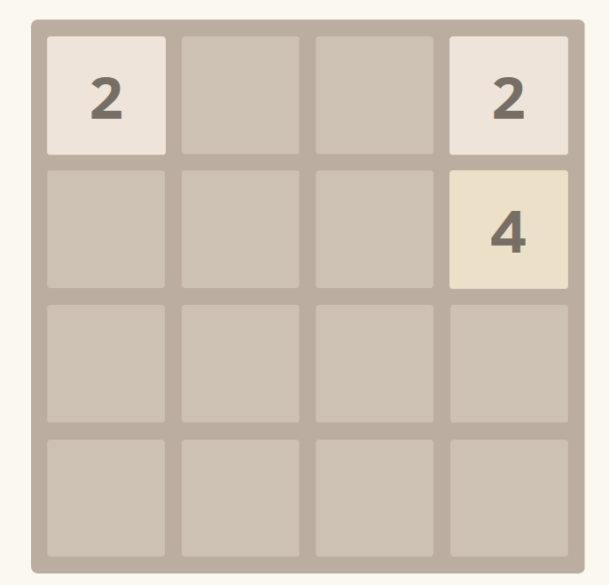 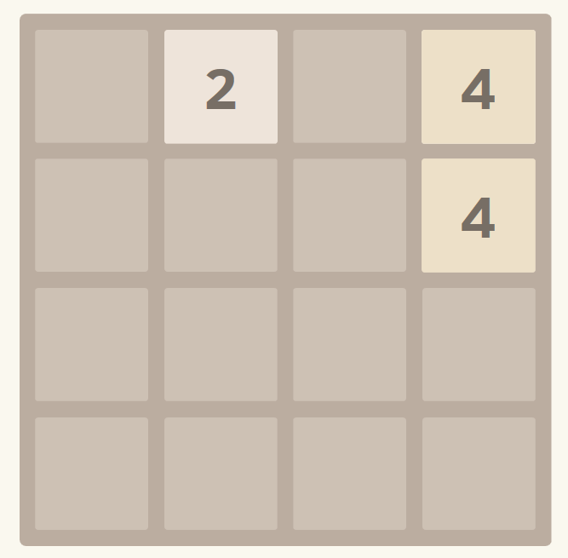

# Milestones

1. Display a 4x4 tiled board -- DONE
2. Make two tiles (2 or 4) randomly appear on empty spaces. -- done
3. Make tiles move when a direction is chosen (w,a,s,d) or (up,down,left right) -- done
4. Make new tiles appear after every move -- done
5. Make adjacent (with same value) tiles in the chosen direction combine -- done
6. Add animation for smooth motion of tiles - not going to do

# Use Cases

|  |  |  |
| --- | --- | --- |
| **Program State** | **Event** | **Program response** |
| There are some tiles on the board | User hits right arrow | Shifts all tiles to the right and combines horizontally adjacent tiles with same value into a single tile with double the initial value. All tiles to the left of combined tile move right to fill the empty space. |
|  | User hits left arrow | Similar to right arrow except that tiles mofe left instead of right. |
|  | User hits up or down arrow | Similar to left or right except vertically adjacent tiles are combined. |
| Tiiles have just been shifted and combined |  | A new tile randomly appears on an empty tile with value 2 or 4 |
| The board is full and no tiles may be combined | User hits an arrow key | Nothing happens, the game is over |

# 

# Class Diagram

